Les 7 en 8 Laravel opdrachten

Agenda controller is aangemaakt:

Route aangemaakt:

AgendaController dingen aangepast:

Agenda tables migration gemaakt:



Create agenda tables aangepast:

Agendas table gemaakt:

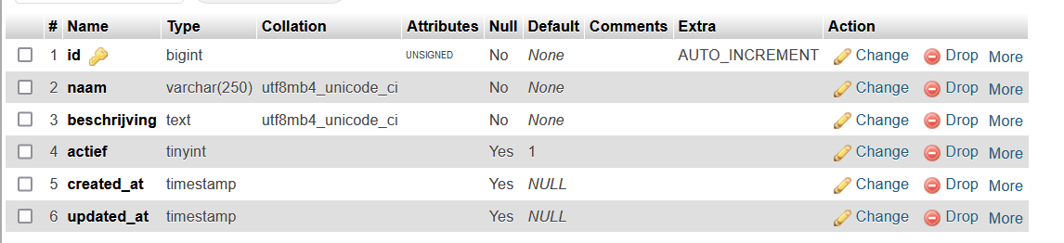

Testedit en testdelete:

